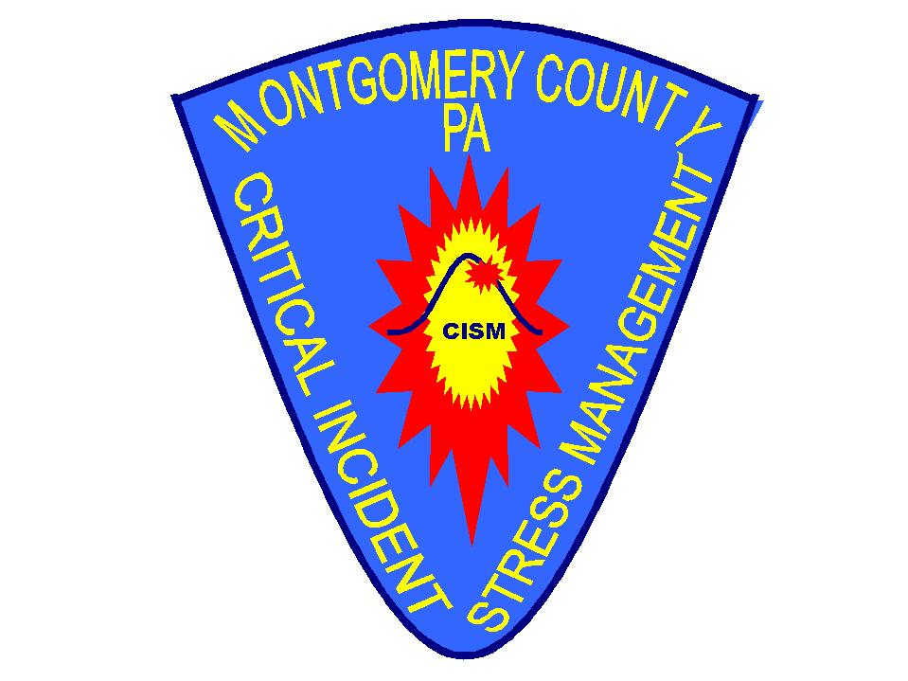
Montgomery County
Critical Incident Stress Management (CISM) Team

Information for Applicants

Referrral Applicants

Application under construction

Please contact the team at cism@pond.com

